Laxmi Charitable Trust’s
Sheth L.U.J College of Arts & Sir M.V. College of Science and Commerce
Department of Information Technology (B.Sc.I.T Semester V)
Data Visualization with Power BI and Tableau
Practical – I
Roll No.:T025 | Name: Afsha Amjad Mujawar
Class:TYIT | Batch:1
Date of Assignment:24-07-2026 | Date/Time of Submission:24-07-2026
Aim:Getting Started with Tableau and Building Basic Visualizations

a) Connect to a CSV dataset and explore the Tableau interface
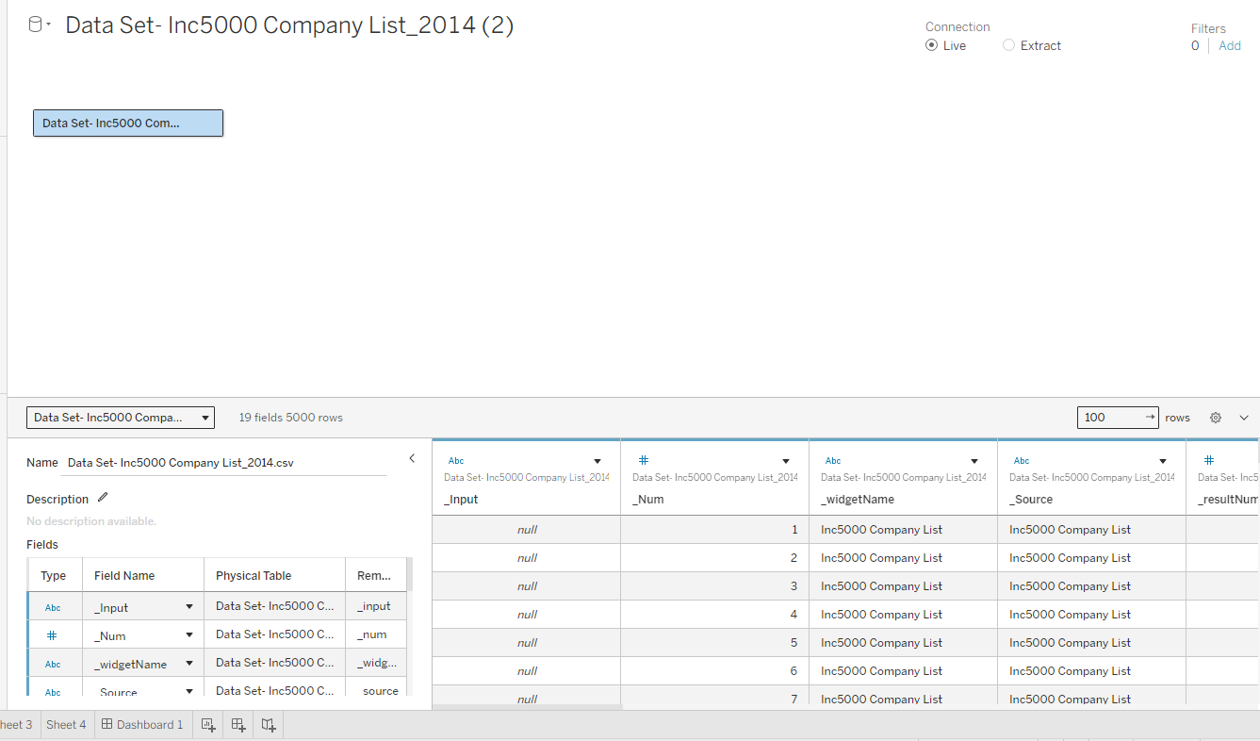

b) Identify and differentiate Measures and Dimensions
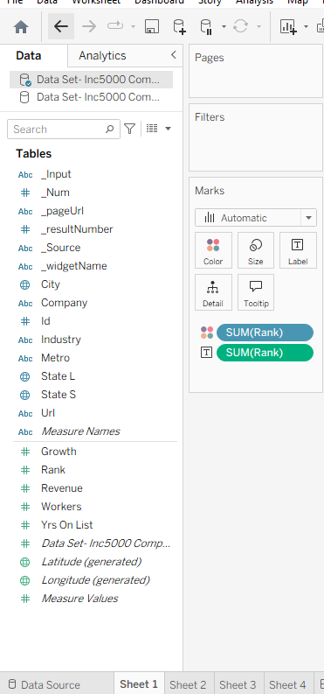

c) Convert fields between discrete and continuous and observe changes
- Discrete
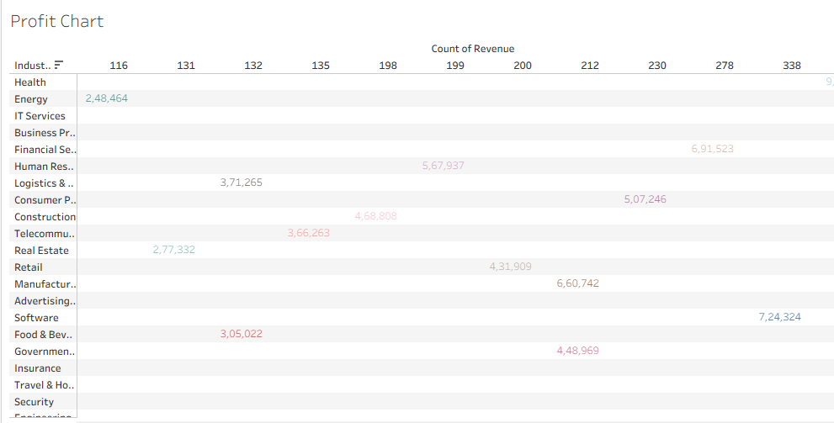
- Continuous :
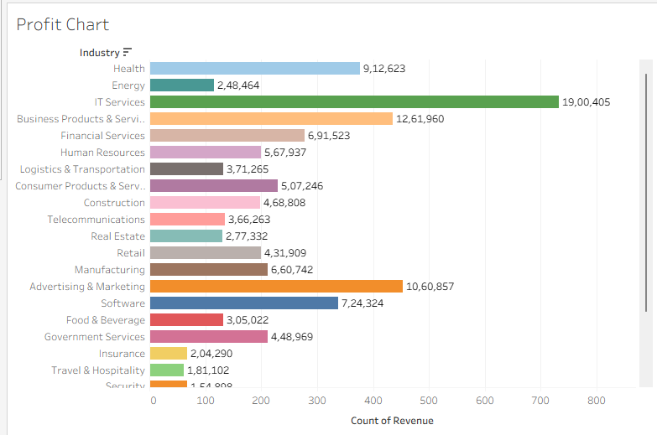
d) Create and customize a basic bar chart
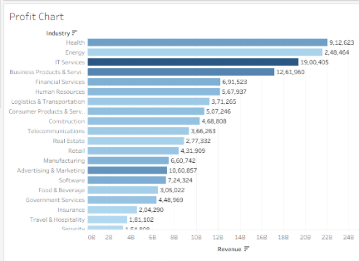
e) Build a line chart for time-series analysis
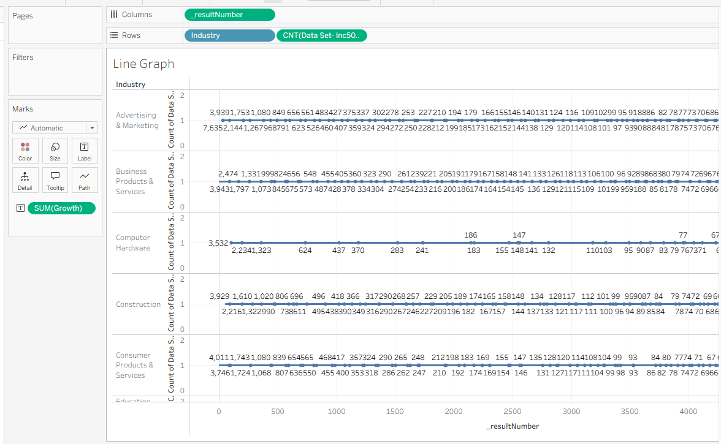
f) Create a geographic map visualization
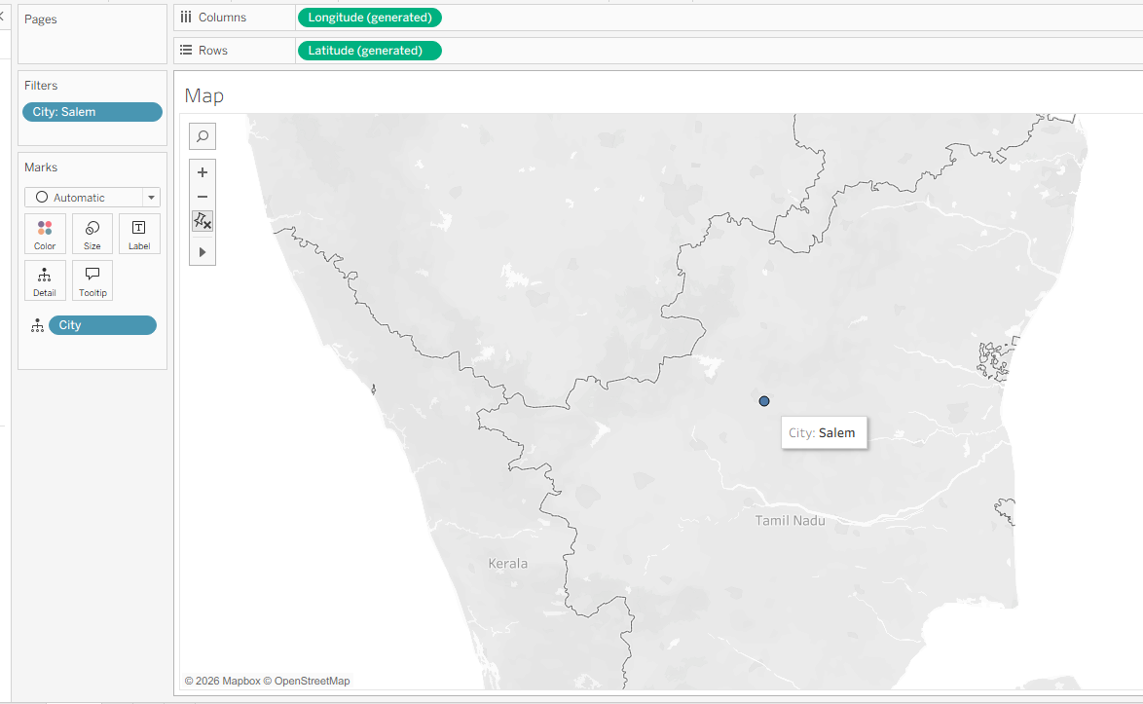
g) Combine multiple charts into a simple interactive dashboard

